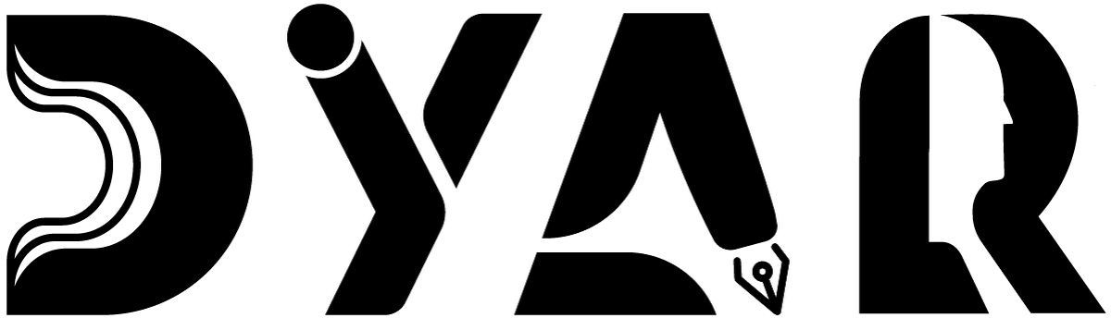
An NDIS Service Provider
RESOURCES HUB · EMERGENCY MANAGEMENT
Emergency Management Plan
What DYAR does when something goes wrong — preparation, response, recovery, and Personal Emergency Evacuation Plans.
Aligned to NDIS Practice Standards · NDIS Code of Conduct · NDIS Act 2013

Version 2 · 12 May 2026
DYAR Pty Ltd
NDIS Provider No. pending (Application 4-LRFP0J8) · ABN 68 695 255 504
Unit 1, 136 Main Street, Osborne Park WA 6017 · PO Box 8052, East Subiaco WA 6008
0470 540 306 · hello@dyar.com.au · Whadjuk Country

Emergency Management Plan (EMP)
What DYAR does when something goes wrong
What's an emergency?
An emergency is when there is real danger.
Examples:
• Fire
• Bushfire
• Big storm or flood
• Medical emergency
• Someone dangerous at the building
• Power outage > 1 hour
• Pandemic alert (like COVID)
DYAR's plan
DYAR has a full Emergency Management Plan that covers:
• How we prepare BEFORE emergencies
• What we do DURING an emergency
• How we recover AFTER an emergency
• Quarterly drills (fire, lockdown, bushfire)
• Personal Emergency Evacuation Plans for participants who need them
Your Personal Emergency Evacuation Plan (PEEP)
If you have mobility, communication, sensory, or other needs that affect how you would evacuate — DYAR creates a PEEP just for you.
Your PEEP describes:
• Your mobility + communication needs
• Your equipment (hoist, sling, oxygen, etc.)
• Your preferred evacuation route
• Who will help you
• Family contact + GP + medications
Use the PEEP Form (Form to be Completed) to start yours.
Where to find DYAR's full plan
• Templates tab — blank EMP templates you can use
• FAQ tab — common questions
• Form to be completed tab — PEEP form for you
• Or call Mehdi: 0470 540 306 — we'll send you the full plan
In an emergency: CALL 000. Then call DYAR — 0470 540 306. We are here day and night for urgent things.
___________________________________________
DYAR Pty Ltd · ABN 68 695 255 504 · Unit 1, 136 Main Street, Osborne Park WA 6017 · 0470 540 306 · hello@dyar.com.au · dyar.com.au · Whadjuk Country · V1 19 May 2026

